API Documentation

Step 1:  
Using postman application for importing collection.

* On the top left click import

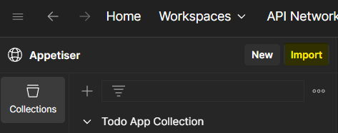

* Next is drag the JSON source file

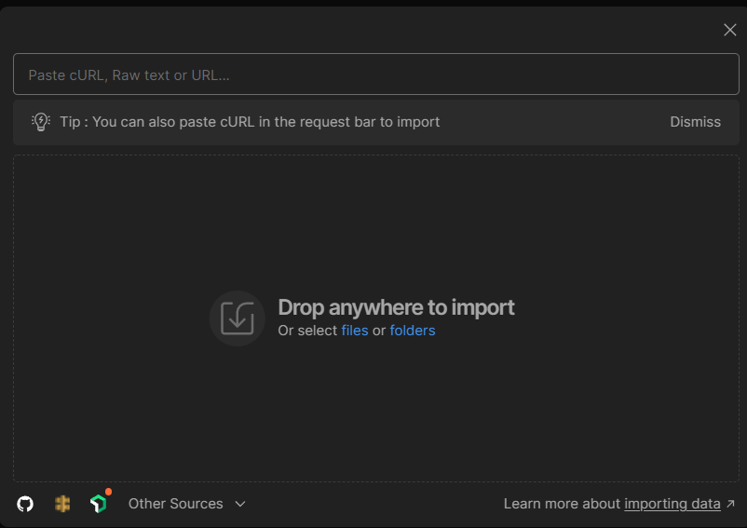

Step 2:

Setup environment

* Click the icon on the right side and create new environment
* Variable host - set the URL of the application in current value
* Variable token – after login you will receive the api_token in response and assign it to current value to access other API calls.

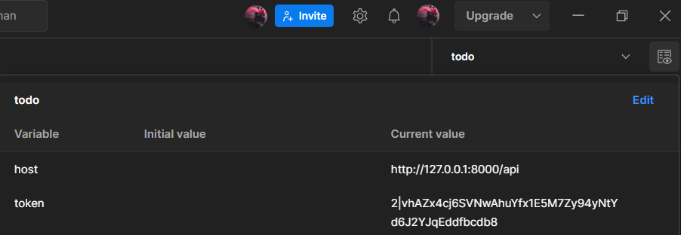

Collection List

**User Folder**

* Register: Use this request to register account
* Endpoint: http://127.0.0.1:8000/api/auth/register

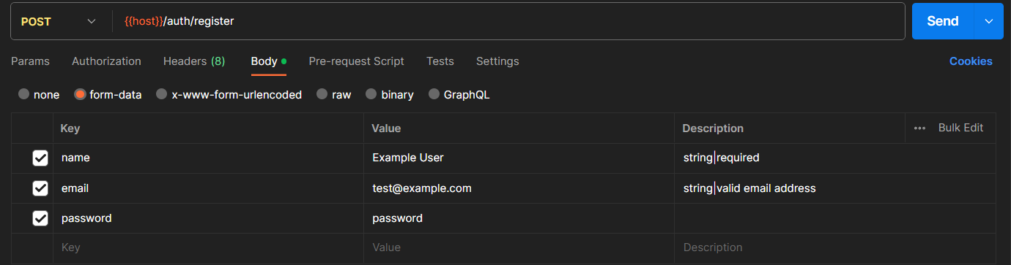

* Login: Use this request to login and get api_token and set to token variable in environment
* Endpoint: http://127.0.0.1:8000/api/auth/login

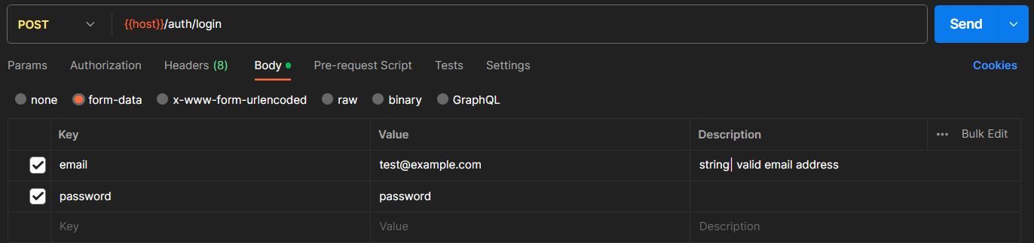

* Profile: Set authorization and input the variable name that we configure earlier
* Endpoint: http://127.0.0.1:8000/api/auth/user/profile

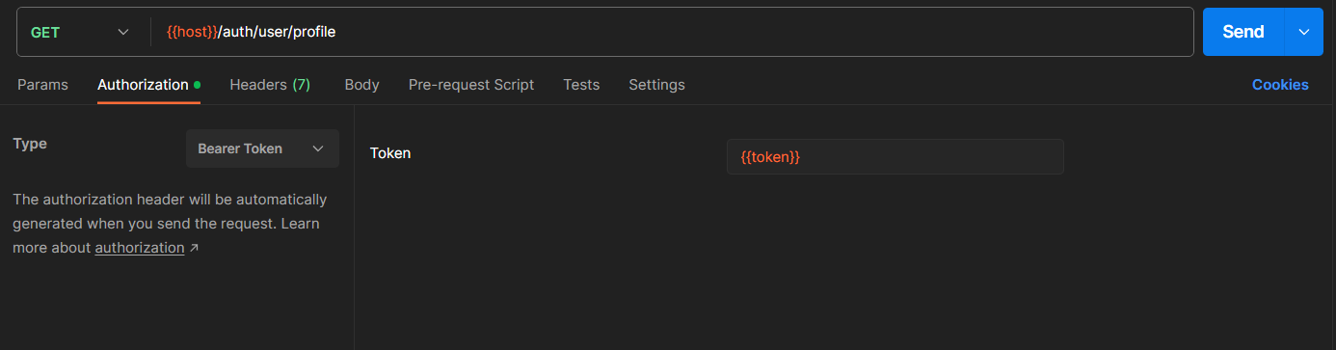

* Logout
* Endpoint: http://127.0.0.1:8000/api/auth/users/logout

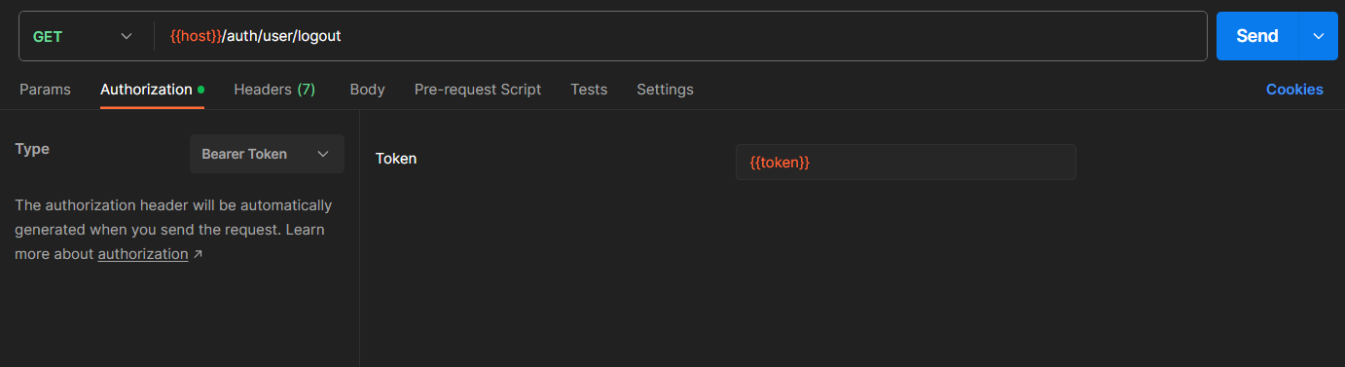

**Todo Folder**

* List: Use this request to get list user todos
* Endpoint: http://127.0.0.1:8000/api/todos/todo

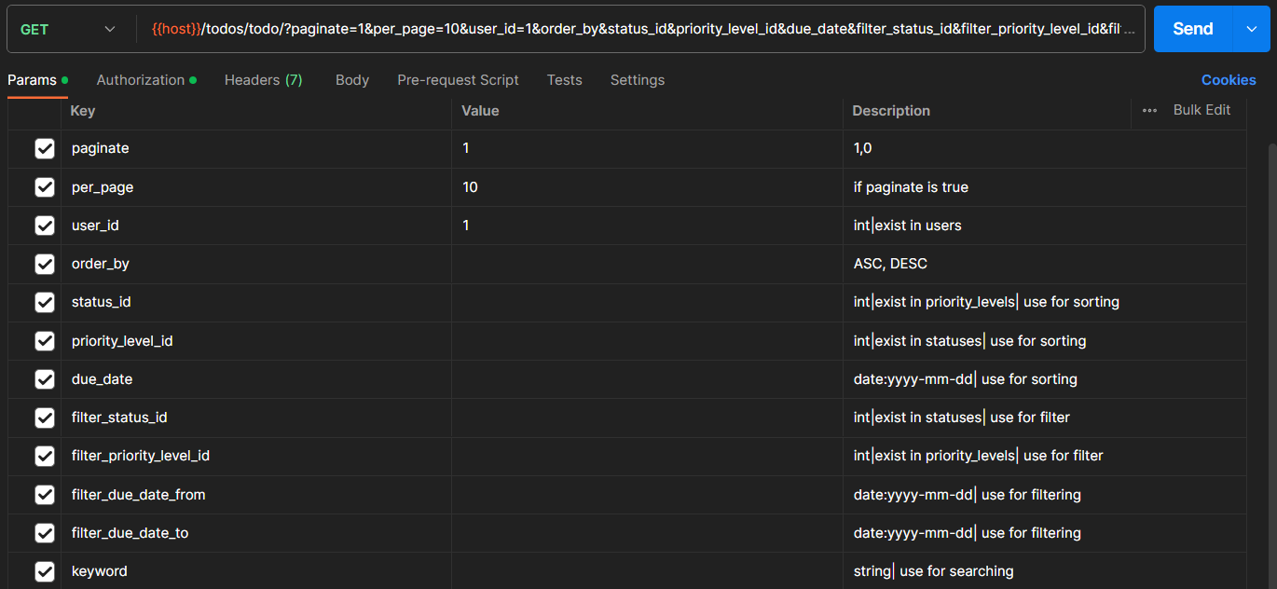

* Store: Use this request to create todo
* Endpoint: http://127.0.0.1:8000/api/todos/todo

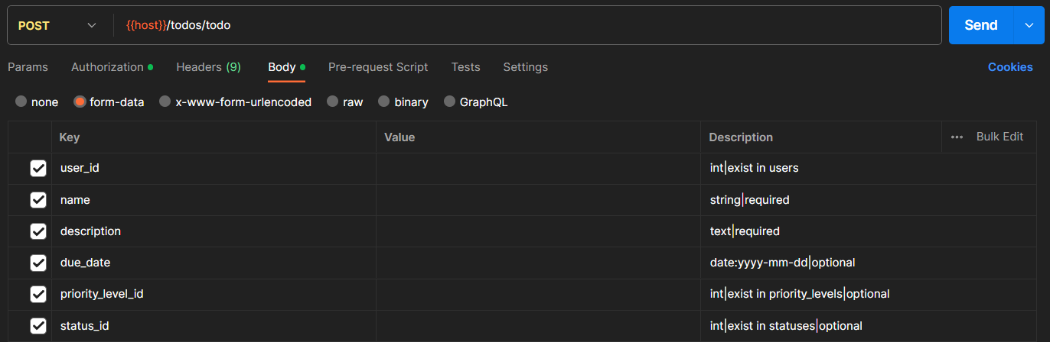

* Update: Use this request to update todo
* Endpoint: http://127.0.0.1:8000/api/todos/todo/{id}

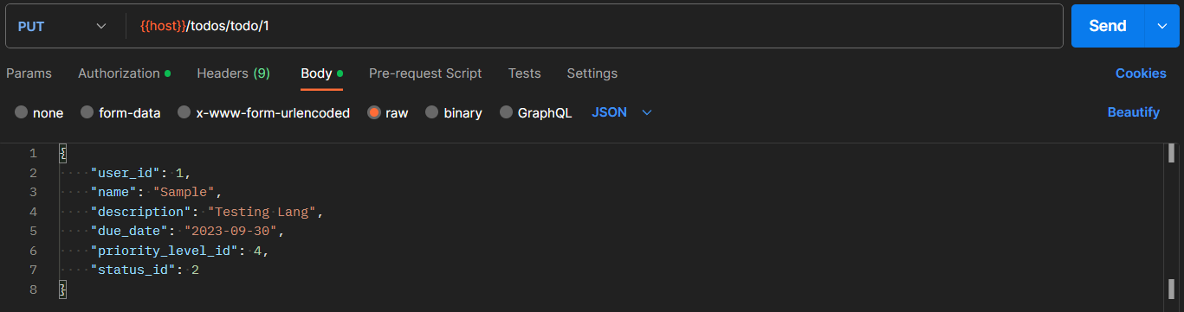

* Update Status: Use this request to mark todo as ‘todo’ or ‘completed’
* Endpoint: http://127.0.0.1:8000/api/todos/update-status/{id}

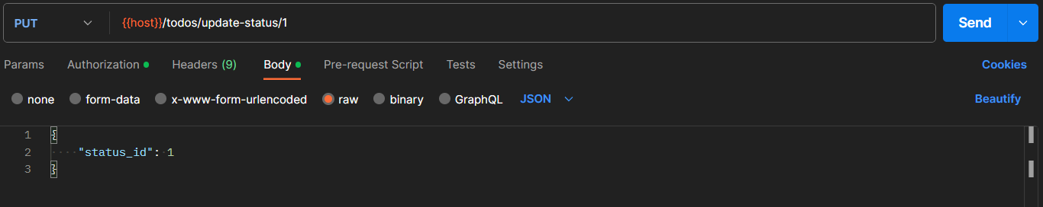

* Show: Use this request to retrieve data of specific todo
* Endpoint: http://127.0.0.1:8000/api/todos/todo/{id}

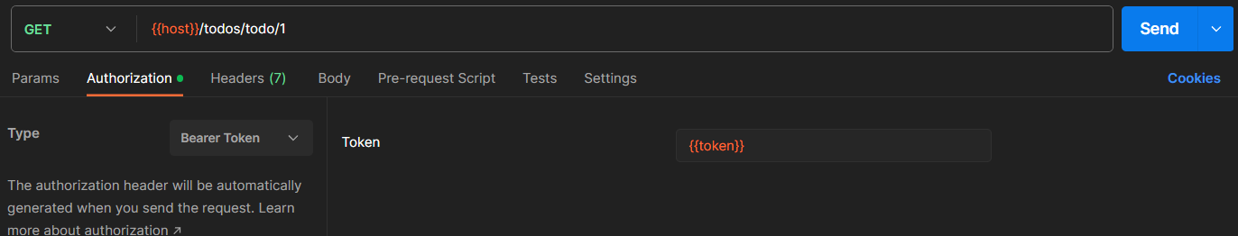

* Delete: Use this request to archive todo
* Endpoint: http://127.0.0.1:8000/api/todos/todo/{id}

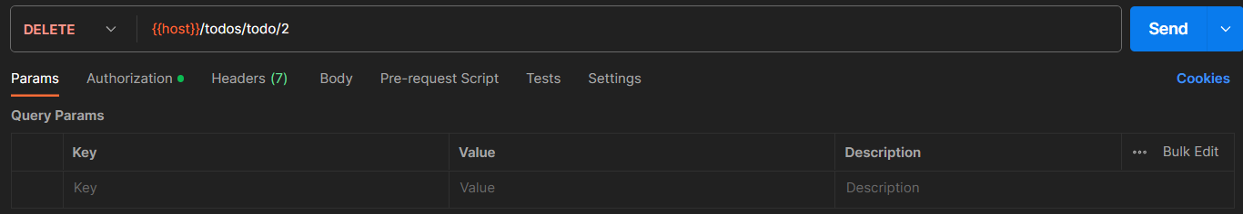

**Archive Todo Folder**

* Store: Use this request to store archived todo. Details is formatted as JSON.
* Endpoint: http://127.0.0.1:8000/api/todos/archive/store

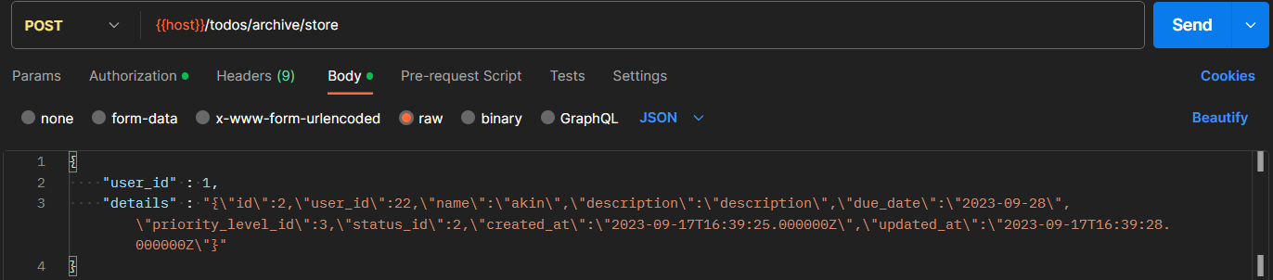

* List: Use this request to get list of archive todos per user
* Endpoint: http://127.0.0.1:8000/api/todos/archive

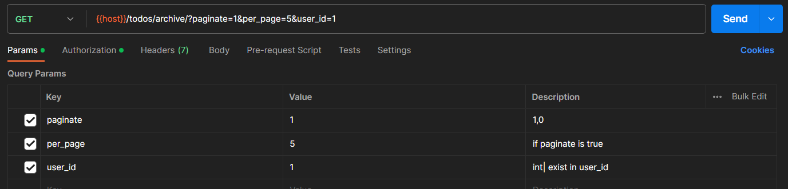

* Delete: Use this request to delete archive request.
* Endpoint: http://127.0.0.1:8000/api/todos/archive/delete/{id}

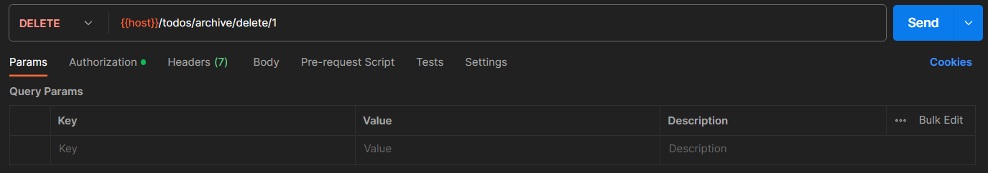

**File Folder**

* Store: Use this request to store image details
* Endpoint: http://127.0.0.1:8000/api/images

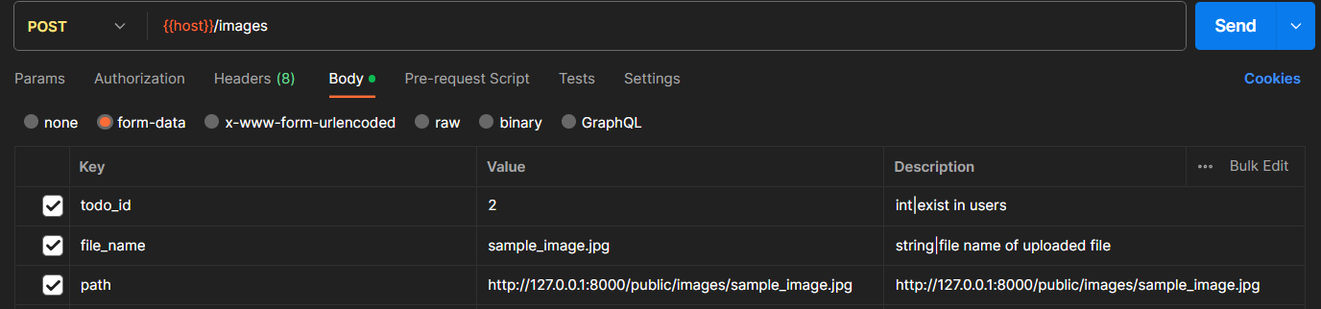

* Delete: Use this request to delete image
* Endpoint: http://127.0.0.1:8000/api/images/{id}

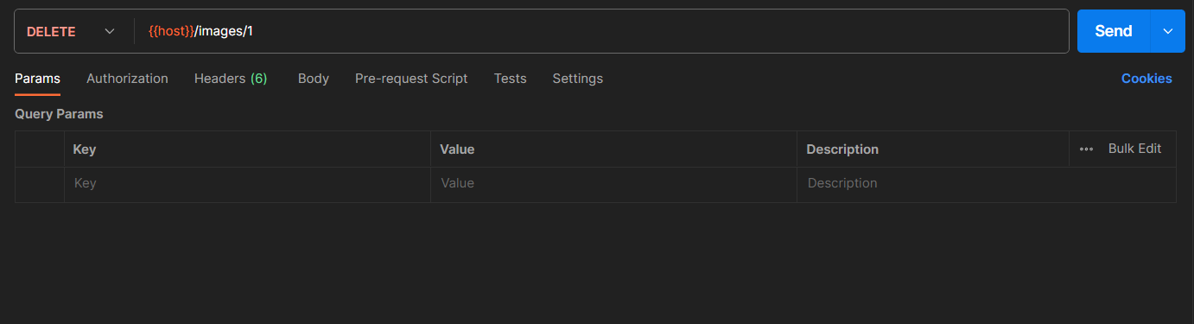

**Tags Folder**

* Store: Use this Request to store tags
* Endpoint: http://127.0.0.1:8000/api/tags

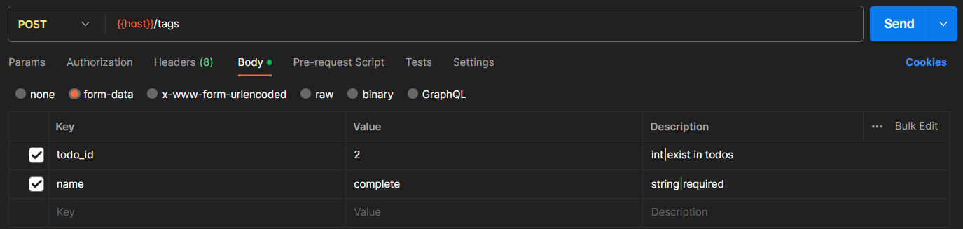

* Delete: Use this request to delete tag
* Endpoint: http://127.0.0.1:8000/api/tags/{id}

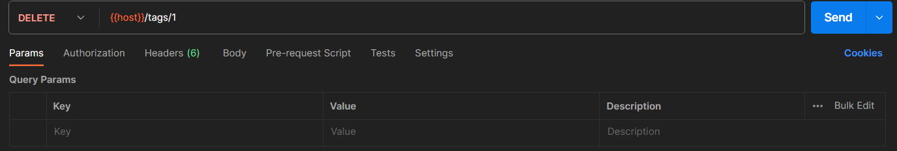

**Options Folder**

* Priority Level List
* Endpoint: http://127.0.0.1:8000/api/options/priority-levels

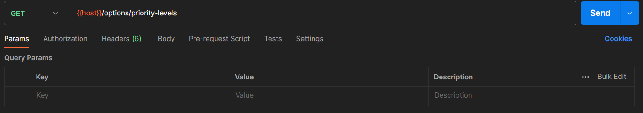

* Status List
* Endpoint: http://127.0.0.1:8000/api/options/statuses

